OFFICIAL COORDINATION REQUEST FOR
NON-ROUTINE OPERATIONS AND MAINTENANCE

COORDINATION TITLE - 20FOS04 Passage Enumeration at Lebanon Dam
COORDINATION DATE - 01 July 2020
PROJECT - South Santiam River (Lebanon Dam)
RESPONSE DATE - 15 July 2020

Description of the problem
To meet BiOp requirements to estimate spawning adult salmon escapement and proportion hatchery origin spawners (pHOS) in the South Santiam River, a Vaki Riverwatcher or similar fish enumeration system will be installed at Lebanon Dam to enumerate fish in 2021 (Figures 1 & 2). Modifications to the North and South Ladders of Lebanon Dam may be necessary. Pending approval (NMFS and others), orifices in the uppermost weir of the North and South Ladders may be blocked so that all fish pass through the monitoring equipment. Interfacing the monitoring equipment with the existing structure will require engineering design and contracting support within the U.S. Army Corps of Engineers (USACE), which may affect when the system is installed. Depending on when the equipment is acquired and installation is approved, South Santiam flows may need to be modified to allow installation. Installation will likely require the ladders to be shut down for up to 1 week. We expect only one ladder will be dewatered at a time to minimize impacts to fish passage. Our current target for installation is February 2021.

http://www.riverwatcher.is/Features/Camerasystem/

Type of outage/change required
Reduced flows at Foster Dam may be required for up to 1 week to allow installation, flow targets will need to be approximately 1,100 cfs. Orifices will be blocked in the uppermost weir of the North and South Ladders so that all fish pass through the monitoring equipment for enumeration beginning next year and into the foreseeable future.

Impact on facility operation
Passage will be impacted through a ladder during the work period. Orifices will be blocked in the uppermost weir of the North and South Ladders so that all fish pass through the monitoring equipment beginning next year (2021) and into the foreseeable future.

Dates of impacts/repairs
Work is targeted to occur February 2021. Orifices will be blocked permanently (as long as fish counting continues into future years) in the uppermost weir of the North and South Ladders.

Length of time for repairs
~ 1 week

Expected impacts on fish
Minimal impacts to fish are expected.

Comments from agencies

North Bank Ladder
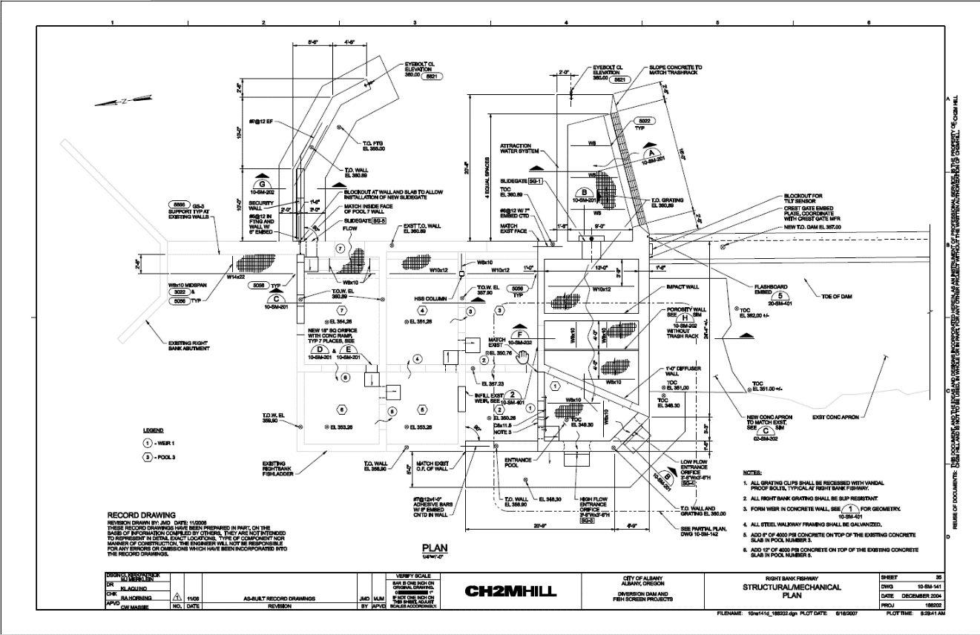

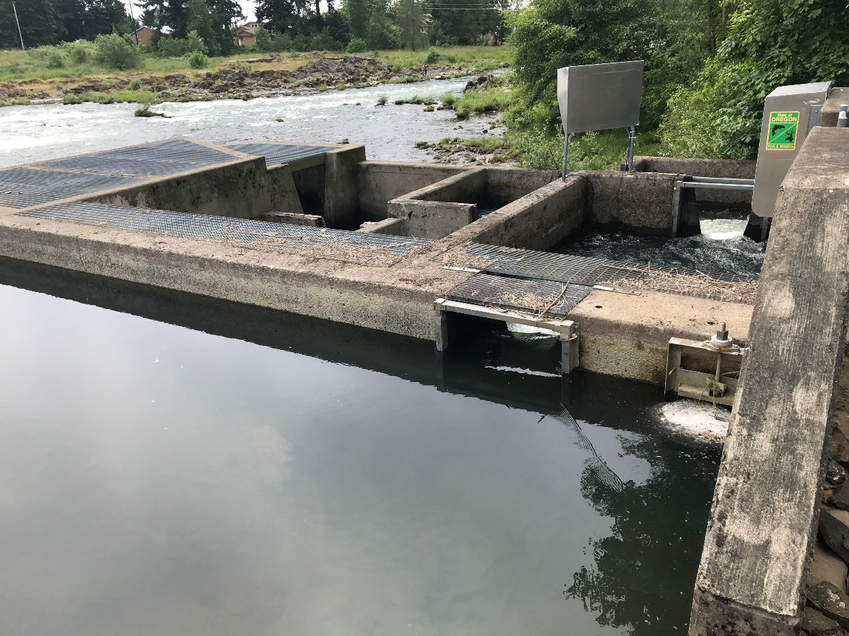
Figure 1

South Bank Ladder
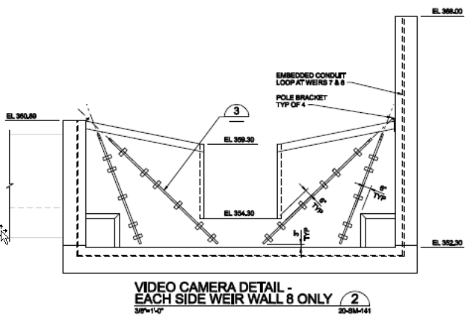

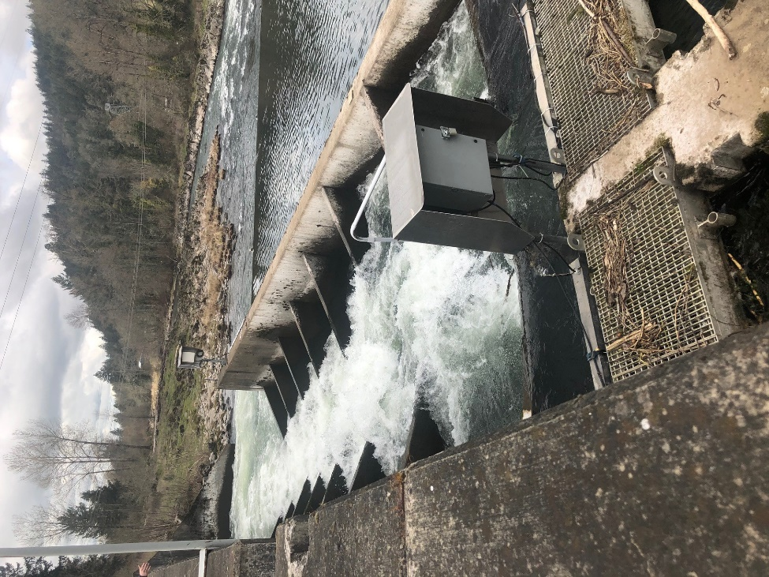

Figure 2
Final results

Please email or call with questions or concerns.
Thank you,

Chris Walker
NWP Operations Division Fishery Section
503.808.4316
Christopher.E.Walker@usace.army.mil

